jps command to check the list of daemons:

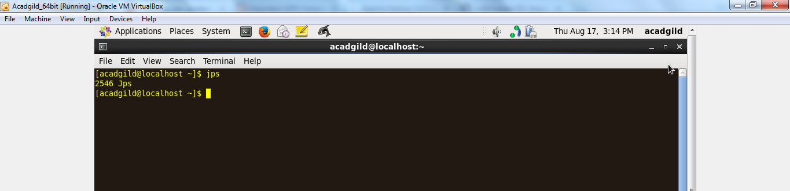

Start SSH server:

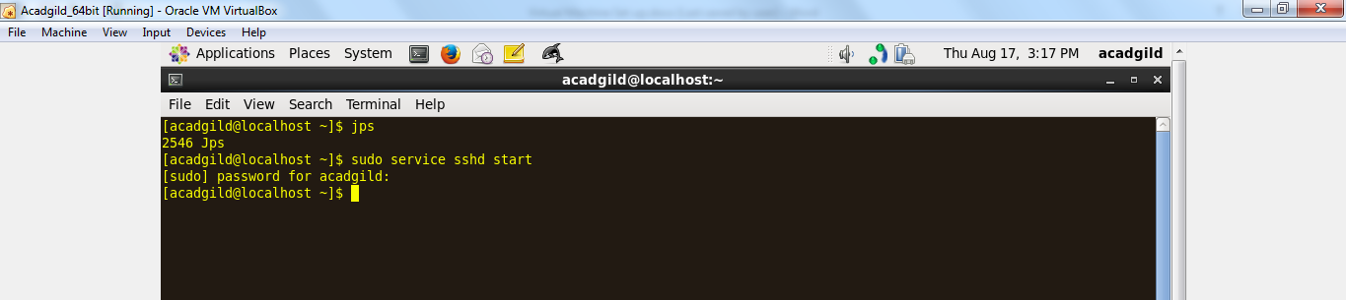

Start all the Daemons:

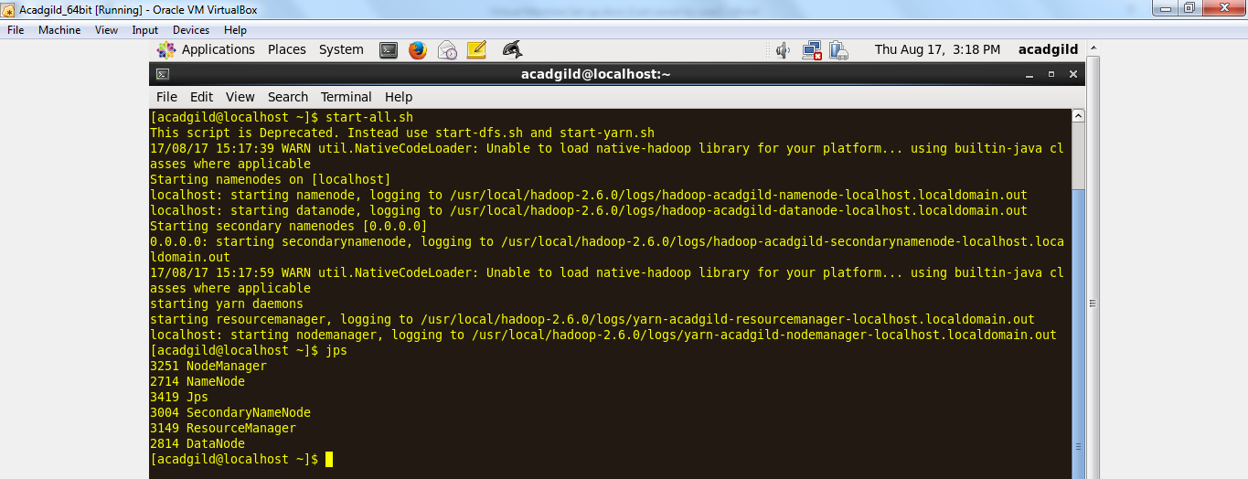

Start the History server:

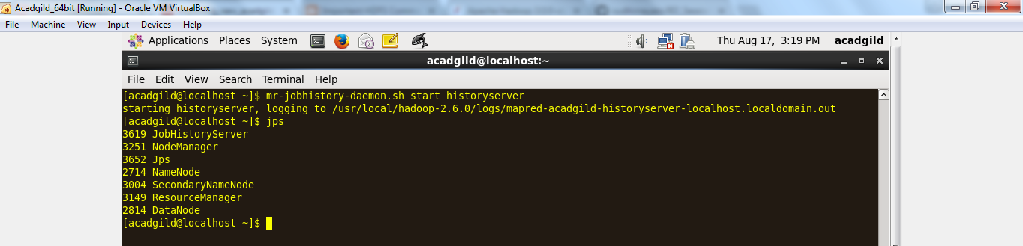

Start Pig in HDFS Mode:

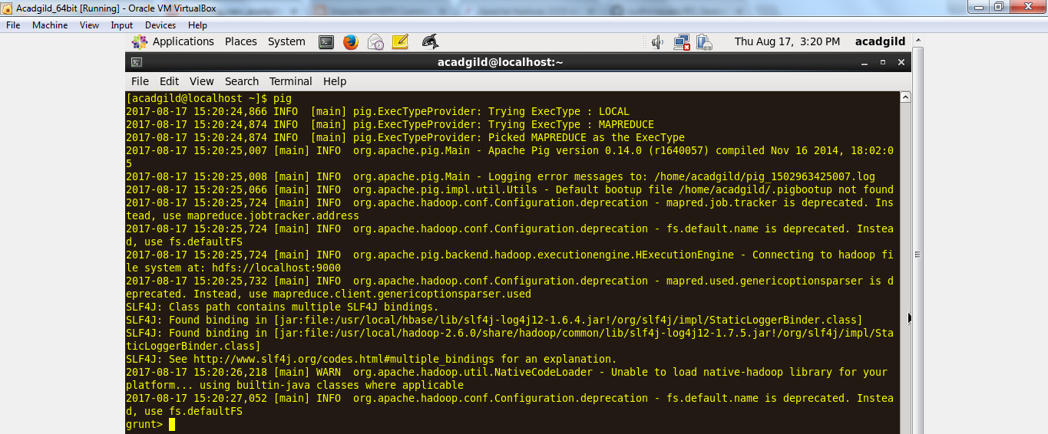

Start MYSQL Service

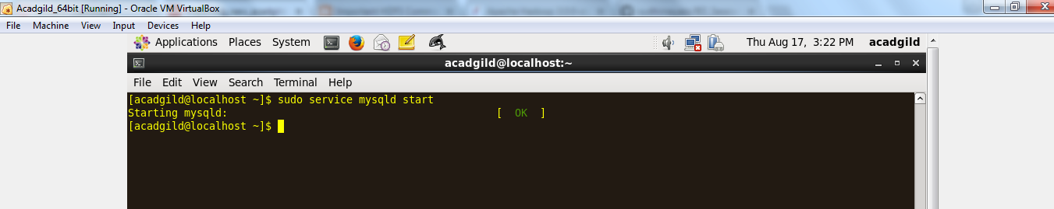

Start HIVE:

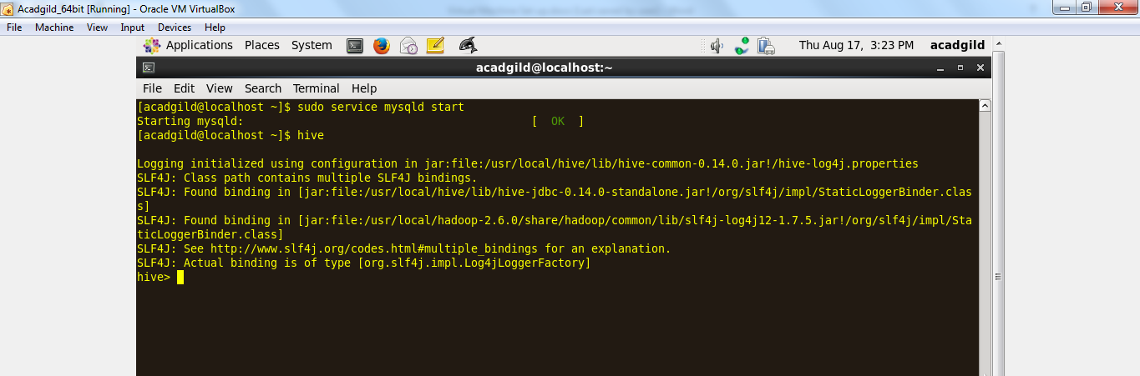

Start HBASE:

